EVENT RULE:

Create an event rule   
this is source event pattern which gives state change on ec2 (pending)

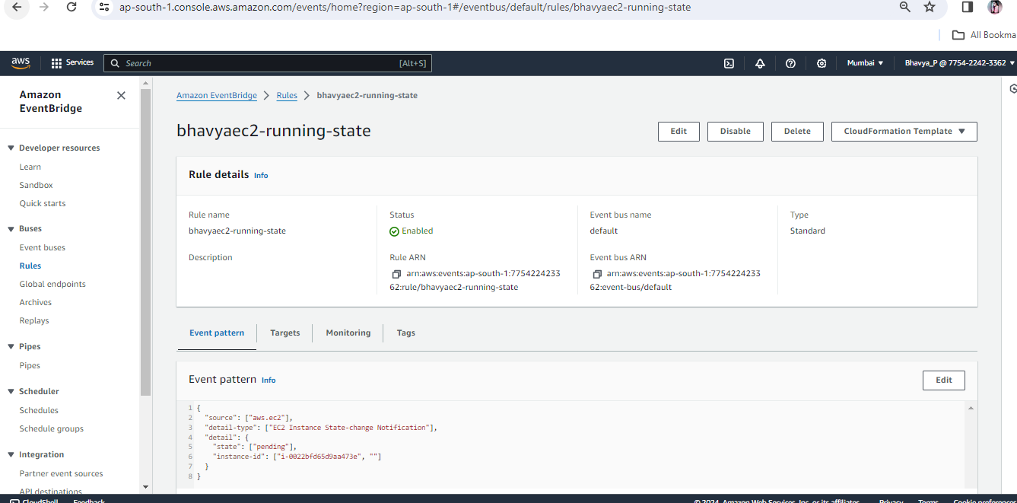

In target innvoke lambda function which would give notification

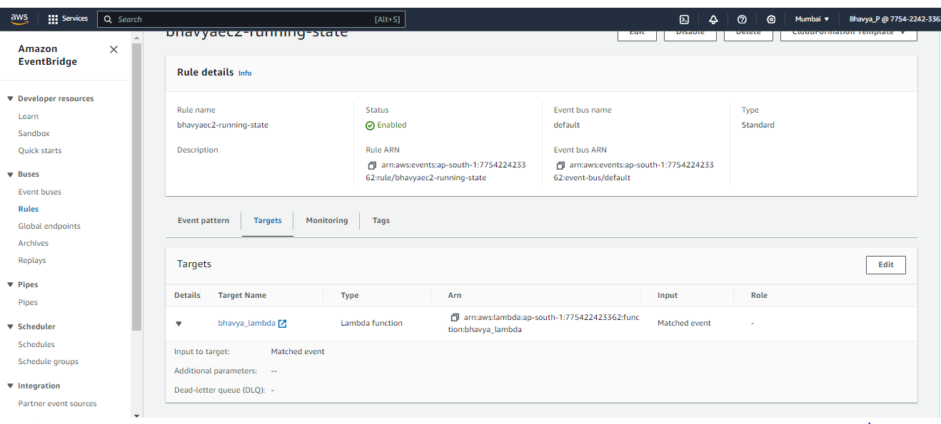

This lambda function goes to sns and gives notification by sending mails

